CSA1205 – COMPUTER ARCHITECTURE

Design and Performance Analysis of a Pipeline Processor with Data Hazard Detection, Forwarding, and Memory Hierarchy
Report Based on the Assignment Required Deliverables
Pipeline Processor with Data Hazard Detection, Forwarding, and Memory Hierarchy

D.G.RAGHAVI (192521173)
S.MAHALAKSHMI (192524372) A.BARANI MUKESH(192521089)

GITHUB LINK

https://github.com/Mahalakshmisarathy/CSA1205-CA.git

- Introduction

Modern computer systems require high performance to execute a large number of instructions efficiently. A pipeline processor improves processor performance by dividing instruction execution into multiple stages and allowing several instructions to be processed simultaneously. This project focuses on the design and performance analysis of a five-stage RISC pipeline processor consisting of Instruction Fetch (IF), Instruction Decode (ID), Execute (EX), Memory Access (MEM), and Write Back (WB).

Although pipelining improves instruction throughput, it can introduce data hazards when one instruction depends on the result produced by a previous instruction. This project studies techniques such as data hazard detection, forwarding, and pipeline stalling to ensure correct execution while minimizing performance loss. In particular, back-to-back dependent instructions and load-use hazards are analyzed to determine when forwarding can resolve a dependency and when a stall is required.

Deliverable Mapping

Deliverable | Implementation Area
1 | Five-Stage RISC Pipeline Processor Design
2 | Pipeline Stage and Instruction Execution Analysis
3 | Data Hazard Identification and Detection
4 | Forwarding Unit Design for RAW Hazard Resolution
5 | Load-Use Hazard Detection and Stall Mechanism
6 | Pipeline Timing Diagram and Hazard Analysis
7 | CPI and Pipeline Performance Comparison
8 | Multi-Level Cache Memory Hierarchy Design
9 | Average Memory Access Time (AMAT) Analysis
10 | Overall Performance Analysis and Design Validation

Deliverable 1: Five-Stage RISC Pipeline Processor Design

Purpose
The purpose of this deliverable is to design a basic five-stage RISC pipeline processor. The processor divides instruction execution into five stages: IF, ID, EX, MEM, and WB. This organization allows multiple instructions to execute simultaneously in different stages.

Design / Pseudocode
START

DEFINE stages = IF, ID, EX, MEM, WB
FOR each instruction FETCH instruction DECODE instruction EXECUTE operation
ACCESS memory if required WRITE result back to register
END FOR

STOP

Sample Input (Python Code)
stages = ["IF", "ID", "EX", "MEM", "WB"]

instructions = ["I1", "I2", "I3"]

for i, instruction in enumerate(instructions): print(instruction, "Pipeline Stages:")

for j, stage in enumerate(stages): print("Cycle", i + j + 1, ":", stage)
print()

Sample Output
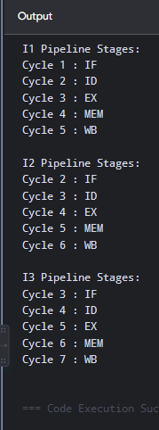

Result / Observation
The five-stage pipeline processor was successfully designed. The instruction execution process is divided into IF, ID, EX, MEM, and WB stages, allowing multiple instructions to overlap during execution..

Deliverable 2: Pipeline Stage and Instruction Execution Analysis
Purpose
The purpose of this deliverable is to analyze how different instructions move through the five pipeline stages. Different instruction types use different hardware resources. Arithmetic instructions mainly use the EX stage, while load and store instructions use the MEM stage..

Design / Pseudocode
START

FOR each instruction
IF instruction is LOAD
IF → ID → EX → MEM → WB

ELSE IF instruction is ADD or SUB IF → ID → EX → WB
ELSE IF instruction is STORE IF → ID → EX → MEM
END FOR STOP

Sample Input (Python Code)
instructions = {
"LW": ["IF", "ID", "EX", "MEM", "WB"],
"ADD": ["IF", "ID", "EX", "WB"],
"SUB": ["IF", "ID", "EX", "WB"],
"SW": ["IF", "ID", "EX", "MEM"]
}
for instruction, stages in instructions.items(): print(instruction, "->", " -> ".join(stages))

Sample Output
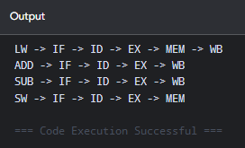

Result / Observation
The analysis successfully identified the pipeline stages required by different instruction types. Load and store instructions require memory access, while arithmetic instructions mainly use the execution stage.

Deliverable 3: Data Hazard Identification and Detection

Purpose
The purpose of this deliverable is to identify data hazards between dependent instructions. A data hazard occurs when an instruction requires a value that is produced by a previous instruction. The most common hazard in a simple RISC pipeline is the Read After Write (RAW) hazard

Design / Pseudocode
START

READ previous instruction destination register READ current instruction source registers
IF previous destination = current source 1 HAZARD = TRUE

ELSE IF previous destination = current source 2 HAZARD = TRUE
ELSE
HAZARD = FALSE

STOP

Sample Input (Python Code)
def detect_hazard(previous_dest, current_src1, current_src2): if previous_dest == current_src1:
return True

if previous_dest == current_src2: return True
return False

hazard = detect_hazard("R1", "R1", "R5") print("Data Hazard Detected:", hazard)

Sample Output
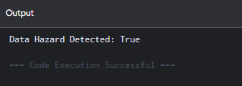

Result / Observation
The program successfully detects RAW data hazards by comparing the destination register of the previous instruction with the source registers of the current instruction.

Deliverable 4: Forwarding Unit Design for RAW Hazard Resolution

Purpose
The purpose of this deliverable is to design a forwarding mechanism that reduces pipeline stalls caused by RAW hazards. Forwarding sends a computed result directly from a later pipeline stage to an earlier execution stage. The dependent instruction does not need to wait until the result is written back into the register file..

Design / Pseudocode
START

IF EX/MEM destination = current source FORWARD from EX/MEM

ELSE IF MEM/WB destination = current source FORWARD from MEM/WB
ELSE
USE register file value

STOP

Sample Input (Python Code)
def forwarding(exmem_dest, memwb_dest, current_source):
if exmem_dest == current_source: return "Forward from EX/MEM"

elif memwb_dest == current_source: return "Forward from MEM/WB"
else:
return "Use Register File"

result = forwarding("R1", "R6", "R1") print(result)

Sample Output
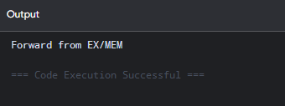

Result / Observation
The forwarding unit successfully resolves arithmetic RAW hazards by transferring the required result directly from pipeline registers without waiting for the WB stage.

Deliverable 5: Load-Use Hazard Detection and Stall Mechanism

Purpose
The purpose of this deliverable is to detect the load-use hazard and insert a pipeline stall when required. A load instruction receives data during the MEM stage. Therefore, an immediately following instruction may require the value before it becomes available. Forwarding alone cannot completely eliminate this hazard in a typical five-stage pipeline.

Design / Pseudocode
START
IF instruction in EX is LOAD IF load destination register =
current source register

INSERT STALL HOLD PC
HOLD IF/ID register

ELSE
CONTINUE STOP

Sample Input (Python Code)
def load_use_hazard(load_dest, current_src1, current_src2): if load_dest == current_src1 or load_dest == current_src2:
return True
return False

hazard = load_use_hazard("R1", "R1", "R4")
if hazard:
print("Load-Use Hazard Detected") print("Insert 1 Stall Cycle")
else:
print("No Stall Required")

Sample Output
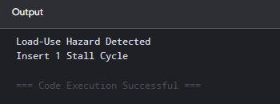

Result / Observation
The load-use hazard was successfully detected. The processor inserts one stall cycle before the dependent instruction continues, ensuring correct execution..

Deliverable 6: Pipeline Timing Diagram and Hazard Analysis4
Purpose
The purpose of this deliverable is to analyze the timing of instructions in a pipelined processor. A timing diagram shows which pipeline stage each instruction occupies during each clock cycle. It helps identify pipeline overlap and stalls. Hazards can be visually observed from the timing sequence.

Design / Pseudocode
START

FOR each instruction ASSIGN IF stage
FOR every next cycle
MOVE instruction to next stage

IF hazard exists INSERT STALL
END FOR
DISPLAY timing diagram STOP

Sample Input (Python Code)
pipeline = [
["LW", "IF", "ID", "EX", "MEM", "WB"],
["ADD", "", "IF", "ID", "STALL", "EX"]
]
for row in pipeline:

print(row[0], ":", row[1:])

Sample Output
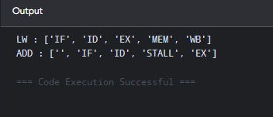

Result / Observation
The pipeline timing analysis successfully shows overlapping execution and identifies the stall required by the load-use hazard.

Deliverable 7: Multi-Level Cache and Virtual Memory Design

Purpose
The purpose of this deliverable is to evaluate processor performance using Cycles Per Instruction (CPI). CPI represents the average number of clock cycles required to execute one instruction.,

Design / Pseudocode
START
INPUT total cycles INPUT total instructions

CPI = total cycles / total instructions DISPLAY CPI
STOP

Sample Input (Python Code)
# instructions = 100
cycles_without_forwarding = 140
cycles_with_forwarding = 110

cpi1 = cycles_without_forwarding / instructions cpi2 = cycles_with_forwarding / instructions
print("CPI without forwarding:", cpi1) print("CPI with forwarding:", cpi2)

Sample Output
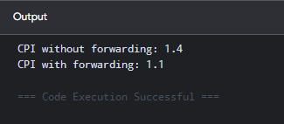

Result / Observation
The performance analysis shows that forwarding reduces CPI from 1.40 to 1.10 under the assumed workload. Therefore, forwarding improves pipeline throughput.

Deliverable 8: Multi-Level Cache Memory Hierarchy Design

Purpose
The purpose of this deliverable is to design a multi-level cache hierarchy for the pipeline processor. Cache memory reduces the time required to access instructions and data. The L1 cache provides the fastest access but has limited capacity. L2 and L3 caches provide larger storage with increased latency.

Design / Pseudocode
START
ACCESS L1 CACHE IF HIT
RETURN DATA

ELSE
ACCESS L2 CACHE

IF HIT
RETURN DATA

ELSE
ACCESS L3 CACHE

IF HIT
RETURN DATA

ELSE
ACCESS MAIN MEMORY

STOP

Sample Input (Python Code)
# cache = {
"L1 Cache": {"Size": "32 KB", "Latency": "1 ns"},

"L2 Cache": {"Size": "512 KB", "Latency": "5 ns"},
"L3 Cache": {"Size": "8 MB", "Latency": "20 ns"},
"Main Memory": {"Size": "8 GB", "Latency": "100 ns"}
}

for level, details in cache.items(): print(level, ":", details)

Sample Output
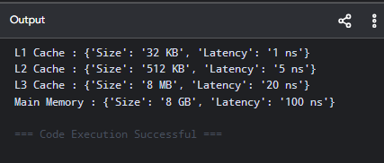

Result / Observation
The multi-level cache hierarchy was successfully designed. The hierarchy balances high-speed cache access with larger memory capacity and reduces dependence on slow main memory.

Deliverable 9: Average Memory Access Time (AMAT) Analysis

Purpose
The purpose of this deliverable is to calculate the Average Memory Access Time of the proposed memory hierarchy. AMAT combines cache hit time, miss rate and miss penalty. It provides a single performance metric for evaluating memory access efficiency. A lower AMAT indicates better memory performance

Design / Pseudocode
START

INPUT L1 hit time INPUT L1 miss rate INPUT L2 hit time INPUT memory penalty
CALCULATE miss penalty CALCULATE AMAT DISPLAY AMAT
STOP

Sample Input (Python Code)
l1_hit_time = 1
l1_miss_rate = 0.05

l2_hit_time = 5
l2_miss_rate = 0.10
memory_penalty = 100

l2_penalty = l2_hit_time + (l2_miss_rate * memory_penalty)
amat = l1_hit_time + (l1_miss_rate * l2_penalty) print("Average Memory Access Time =", amat, "ns")

Sample Output
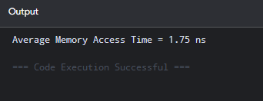

Result / Observation
The AMAT of the memory hierarchy was calculated as 1.75 ns for the assumed parameters. The cache hierarchy significantly reduces the average memory access time compared with direct main-memory access.

Deliverable 10: Overall Performance Analysis and Design Validation

Purpose
The purpose of this deliverable is to combine the results of pipeline hazard analysis and memory hierarchy analysis. Processor performance depends on both instruction execution efficiency and memory access latency. Forwarding reduces data hazard penalties and lowers CPI

Design / Pseudocode
START

CALCULATE CPI without forwarding CALCULATE CPI with forwarding CALCULATE AMAT
COMPARE results
IF CPI decreases AND AMAT decreases PERFORMANCE IMPROVED
DISPLAY FINAL RESULT STOP

Sample Input (Python Code)
cpi_without_forwarding = 1.40
cpi_with_forwarding = 1.10

amat = 1.75
print("PERFORMANCE ANALYSIS")

print("CPI without forwarding:", cpi_without_forwarding)
print("CPI with forwarding:", cpi_with_forwarding)

print("AMAT:",
amat, "ns")
if cpi_with_forwarding < cpi_without_forwarding: print("Pipeline performance improved")

print("Processor design validated successfully")

Sample Output
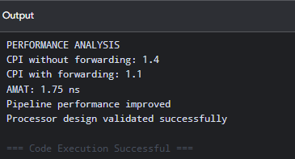

Result / Observation
The overall analysis confirms that the proposed processor design improves performance through pipelining, hazard detection, forwarding and multi-level cache memory. Forwarding reduces the CPI, while the cache hierarchy reduces average memory access latency. Therefore, the final processor design provides better overall performance and efficiency.

Overall Conclusion
This project successfully designed and analyzed a five-stage RISC pipeline processor with data hazard detection, forwarding, and a multi-level memory hierarchy. The processor pipeline consists of the Instruction Fetch (IF), Instruction Decode (ID), Execute (EX), Memory Access (MEM), and Write Back (WB) stages, which allow multiple instructions to be processed simultaneously and improve overall instruction throughput.The analysis demonstrated that data hazards, particularly Read After Write (RAW) hazards, can reduce pipeline performance when dependent instructions occur consecutively. A hazard detection mechanism was used to identify these dependencies, while

forwarding was applied to transfer results directly between pipeline stages and reduce unnecessary stalls. For load-use hazards, where the required data is not immediately available, a controlled pipeline stall was introduced to ensure correct execution.

PLAGIARISM REPORT



